DIVERSITY OF ORCHID SPECIES IN GUANACAS RESERVE
ANTIOQUIA - COLOMBIA

Progress Report No. 2

By:
Esteban Domínguez Vargas
Biology Student - Orchidaceae Specialist
Schultes Research Group, ECOTONOS Foundation;
Colombian Orchid Study Group GEOC;
University of Antioquia Herbarium: HUA

Translated by:
María Alejandra Moreno Vásquez
Project manager

Fundación Guanacas Bosques de Niebla

September - October de 2020
Medellín – Colombia

PRESENTATION

The preliminary results of the exploration and collection stage of one of the most forested areas of the Guanacas Reserve is presented in this report. In October 2020, the second expedition of the project “DIVERSITY OF ORCHID SPECIES IN GUANACAS RESERVE,” was carried out, in which specimens of different groups of plants were collected, with special emphasis on the Orchidaceae family. The material was collected in the field, dried in the Herbarium of the Botanical Garden of Medellín (JAUM) and currently is in the process of assembly and exhaustive identification. An updated list of the species accumulated so far is attached, after the two expeditions corresponding to the project and another corresponding to a field trip of an external project. The field trip was made effective with the accompaniment of three other botanists linked to the JAUM within the framework of the project that has been possible thanks to the grant approved by the American Orchid Society.

INTRODUCTION

Orchids, without a doubt, constitute not only the group of flowering plants (angiosperms) with the largest number of species in the world, but also one of the most charismatic of the plant kingdom. The particular shapes and attractive colors of its flowers have historically attracted the attention of naturalists, horticulturists, taxonomists, artists, and society in general, which recreates in them, the greatest inspiration that nature could express in a flower. Even for the most profane in the knowledge of plants, the concept of orchid is synonymous with high expression of beauty, design and color. Orchids, like no other flower, have touched the most intimate fiber of sensitivity of human beings, thus becoming a natural reference to admire and contemplate in the plant world.

It has been estimated that almost 40% of all the species registered in Colombia are endemic to some biogeographic region of the country with the Andean region as the area with the highest rate of orchid endemism at the national level (Minambiente and U. Nal de Colombia 2015). Such is the importance of this group in Colombia that even the Colombian Academy of History designated, in 1936, the Cattleya trianae as the national emblematic flower. However, orchid populations in the Neotropics are increasingly affected by the exaggerated overcollection of farmers hired by feverish collectors, which makes them put on the brink of extinction, and therefore, they are commonly found on the international red lists of species categorized by some degree of threat; being included within the second criterion of the IUCN as species of prohibited use.

The Guanacas Reserve is located in the municipality of Santa Rosa de Osos, in the Intermediate Plateau of the Central Andean Mountain Range at altitudes between 2,000 - 3,000 meters above sea level (L.A. Arias, 2011). It has an area of ​​750 hectares and is located in one of the most deforested Colombian landscapes by extensive dairy and cattle areas at the North of Antioquia. Making any conservation effort in such a landscape filled with pastures is an odyssey specially to maintain the connection of remaining biological corridors.

The project "Diversity of orchid species in the Guanacas Reserve" approaches the knowledge of the presence of species of the Orchidaceae family within this territory. Orchids, are not only plants of exuberant colors and shapes, but they are also an important group for the functioning of natural ecosystems, fulfilling the function of regulators of the populations of their pollinators, for example, by maintaining humidity and the relationship with microorganisms and mycorrhizae. It is then that by knowing not only their taxonomy, but also their ecology, this project highlights the importance of these wonderful plants within their different ecosystems and the projection of future research proposals on the site. However, it is important to note that the results of the final inventory will be used in the preparation of future field guides for the use of locals and visitors and that will lead to a possible profitable income, not only for the Guanacas Foundation but also for the inhabitants of nearby places.

Supporting these types of projects brings together various independent research groups and local researchers, in order to build shoulder to shoulder the much-mentioned sustainable development of rural regions, as well as the conservation of native and even endemic species. When the knowledge of where we are becomes great and common among the common people, then we can say that it becomes a public property to own and defend our territories from exploitation that impede the socio-economic development of the local regions.

METHODOLOGY
The methodology used was based mainly on the general collection regarding the routes proposed by the local guide and the invited botanical specialists.
The sampling sites were previously selected with the premise of covering the most conserved forests and sites with little representativeness in the previous field trip.
The Montañitas sector was chosen as base camp, located to the west of the Guanacas Reserve, near Cerro San José, which has a height of 2886 meters above sea level, and is the highest hill in the municipality of Santa Rosa de Osos, Antioquia.
The sampling of the Orchidaceae family focused on obtaining a piece or complete plant showing all its adult and reproductive stages, that is, at least 3 bulbs or ramicaules; with full leaves and inflorescence, preferably with open flowers; enough roots where their thickness is perceived. Additionally, fresh or solution collections were made (Alcohol, water and glycerin) of the flowers, inflorescences or necessary additional tissue.
Subsequently, these samples were alcoholized and pressed in the field, using newspaper and transparent heavy-gauge bags, each with its corresponding research code.
The samples were then taken to the JAUM where they were dried at 65°C for three consecutive days in a special oven for botanical samples, pressed with high mechanical pressure between cardboard and aluminum. Then an arduous process of identification and determination of the individuals collected in the herbaria was carried out. For the project, the herbaria of the CES University (CBUCES), the University of Antioquia (HUA) and the Botanical Garden of Medellin (JAUM) were selected as herbaria where the original sample or collection, the first and second duplicate, respectively, will be stored.
From then on, the necessary analyses are being carried out to obtain arguments through these data represented in the samples and collections that would be finally attached to a thick white cardboard with liquid glue and thread, becoming a witness specimen of the conservation of the site.
In addition to the above, the collected specimens were documented with high resolution photographs that could lead to scientific illustrations, Lankester-type plates (LCDP) and subsequent publications.
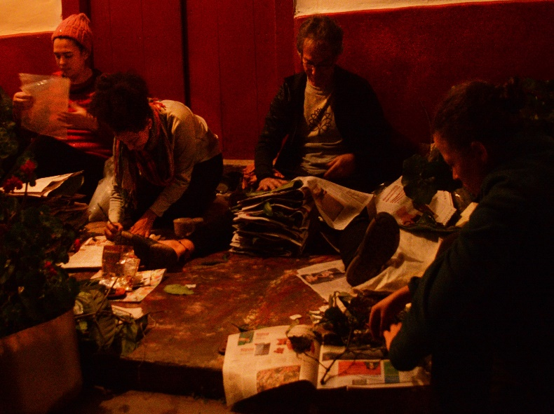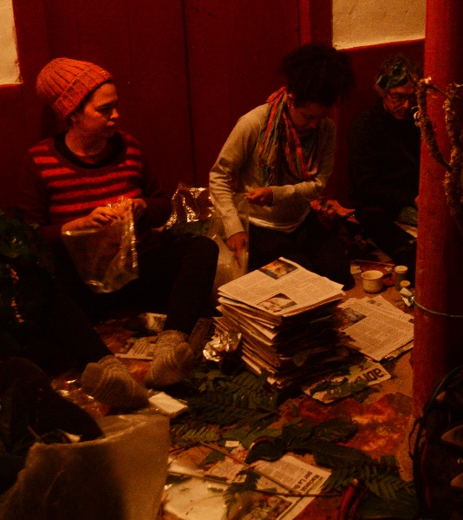
Fig. 1. Botanical pressing method

RESULTS
During the second effective expedition of the project, two alternate botanists were present, who contributed a great deal of knowledge and collected approximately 200 individuals of at least another 150 plant species corresponding to other families of botanical and taxonomic interest, in which the great majority corresponded to host trees of orchids and other epiphytes.
For the Orchidaceae family, a total of 130 morphospecies were obtained, distributed in 28 genera (Table 1). This cumulative list includes the morphospecies recorded in the first and second expedition, as well as some species that had been recorded as a baseline from previous inventories in the Guanacas Reserve.
The best represented genera were in order: Pleurothallis (22 individuals), Epidendrum (21 individuals), Stelis (20 individuals), Lepanthes (16 individuals), Maxillaria (10 individuals) and Elleanthus (6 individuals). The Pleurothallidiinae is more numerous and locally diverse, the elevations and air moisture of the Andean cloud forests promotes the presence of species with pseudobulbs.
In addition, it should be noted that 16 morphospecies whose record is pioneering for the region are not collected very often even at the national level (*).
Also 6 of the morphospecies collected are believed to be undescribed species and probable new to science (**). This should be treated with extreme caution until the evidence is fully verified with international peers and specialists of the genera in question. This means that several of these species may already have some identity, but they must be reviewed to achieve their thorough and accurate determination in the processes of identification through the herbarium and exchange of knowledge with other researchers, and/or description and subsequent publication as new species for science in international and indexed scientific journals.
Finally, 2 of the morphospecies collected, are known to be effectively new to science and are in the process of description and publication (***).
Table 1. Cumulative orchid species list of the Guanacas Reserve
Guanacas Reserve Orchid Species
Acianthera rodrigoi*
Andinia hippocrepica
Andinia pilosella
Barbosella sp.
Chrysocycnis ecuadorense
Cranichis sp.
Cyrtochilum annulare
Cyrtochilum cf. cimiciferum
Cyrtochilum cf. flexuosum
Cyrtochilum divaricatum
Cyrtochilum ventilabrum
Elleanthus ampliflorus*
Elleanthus aurantiacus
Elleanthus lupulinus
Elleanthus maculatus
Elleanthus purpureus
Elleanthus robustus
Epidendrum (híbrido natural amarillo)
Epidendrum (híbrido natural lila)
Epidendrum aff. recurvitepalostachyum**
Epidendrum arachnoglossum
Epidendrum aura-usecheae*
Epidendrum blepharistes
Epidendrum cernuum
Epidendrum cf. igneum
Epidendrum cf. imperator
Epidendrum cilyndrostachys
Epidendrum elleanthoides
Epidendrum envigadoense
Epidendrum fimbriatum
Epidendrum geminiflorum
Epidendrum jajense
Epidendrum megalospathum
Epidendrum melinanthum
Epidendrum scytocladium
Epidendrum sp. (aff. schlimii)
Epidendrum sp. (chiquitico)
Epidendrum stanhopeanum
Frondaria caulescens (Lindl.) Luer*
Frondaria sp.
Gomphichis cf. bogotensis
Lepanthes acarina
Lepanthes agglutinata
Lepanthes cf. ophelma*
Lepanthes ferax
Lepanthes gargantua*
Lepanthes mucronata
Lepanthes mucronata (hoja alargada)
Lepanthes mucronata (hoja elíptica)
Lepanthes pilosiaures
Lepanthes sp nov. (aff. elata)**
Lepanthes sp nov. (aff. escifera)***
Lepanthes sp nov. (aff. ribes)***
Lepanthes sp. nov. (aff. felis)**
Lepanthes tachirensis
Lepanthes tibouchinicola*
Lepanthes wageneri
Lepanthopsis peniculus (Schltr.) Garay*
Masdevallia tubulosa
Maxillaria acuminata
Maxillaria aequiloba
Maxillaria aff. embreei
Maxillaria aggregata
Maxillaria alticola
Maxillaria aurea
Maxillaria deuteropastensis
Maxillaria gigantea
Maxillaria nubigena
Maxillaria palmensis
Odontoglossum sceptrum*
Oncidium cf. anomalum
Oncidium ornithorynchum
Pachyphyllum (ancho)
Pachyphyllum crystallinum
Pachyphyllum sp.
Platystele consobrina
Platystele orectoglossa
Pleurothallis aves-seriales
Pleurothallis cf. chloroleuca**
Pleurothallis cf. elegans
Pleurothallis cf. fossulata*
Pleurothallis cf. galeata
Pleurothallis cf. gomezii**
Pleurothallis fugax
Pleurothallis lopezii
Pleurothallis magdalenae*
Pleurothallis megalorhina
Pleurothallis phalangifera
Pleurothallis pulvinaris
Pleurothallis punctata
Pleurothallis sigsigensis*
Pleurothallis sp. (Grupo Chloroleuca)
Pleurothallis sp. (grupo Lindenii)
Pleurothallis sp. (Sect. Crocodeilanthe)
Pleurothallis sp. 1
Pleurothallis sp. 2
Pleurothallis strobilifera (Macrophylae-Racemosae) Variedad Tipo
Pleurothallis strobilifera (Var. Xanthina; Sub. Sección Macrophylae-Racemosae)
Pleurothallis strobilifera Var. Xanthina
Porroglossum muscosum
Porroglossum sp.*
Prosthechea cf. hartwegii
Pseudolepanthes calceolaris*
Pterostema antioquensis*
Scaphosepalum antenniferum
Scaphyglottis aurea
Scaphyglottis grandiflora
Sobralia sp.
Sobralia virginalis
Stelis acutissima*
Stelis aff. asseris
Stelis aff. orphana
Stelis aff. patella
Stelis aff. pusilla
Stelis angustifolia
Stelis angustifolia (doble amarilla)
Stelis cf. capuligera
Stelis cf. eugenii
Stelis cf. titanica
Stelis famelica
Stelis sauveolens
Stelis sp (escandente)
Stelis sp. (curva amarilla pequeña 1)
Stelis sp. (peludita)
Stelis sp. 1
Stelis sp. 2
Stelis sp. 3
Stelis sp. 4
Stelis sp. 5
Stenorrhynchos sp nov.**
TOTAL: 130
* Not collected very often, pioneer record for the region.
** Probable new species
*** New species in process of description

Some of the species tabulated and highlighted above are briefly illustrated below:
Table 2. Description and photograph of some of the species recorded
Acianthera rodrigoi (Luer) Luer  It is a little-known species, perhaps it has been traditionally confused with A. sicaria. It is endemic to the department of Antioquia and the central mountain range. It is found in higher and more humid areas near streams. http://www.orchidspecies.com/pleurrodrigoi.htm | Acianthera rodrigoi (Luer) Luer
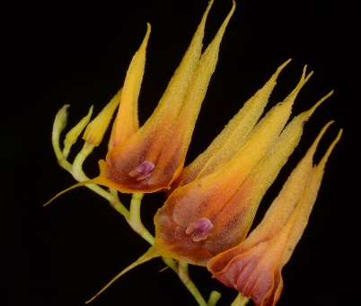  Lepanthes tibouchinicola Luer & R.Escobar | Lepanthes tibouchinicola Luer & R.Escobar  A highly conspicuous species due to its yellow and bright orange shades; it grows on trees that are commonly called "sietecueros" (Tibouchina lepidota), which deserves its name, as it has been recorded that they prefer this species as a host. Its flowers can reach up to 2cm in length and its inflorescences up to 25cm. It is a species endemic to the north of the central and western mountain ranges in Colombia. http://www.orchidspecies.com/leptibouchinicola.htm
Lepanthopsis peniculus (Schltr.) Garay  An important record, since it was only known from the Eastern Cordillera of Colombia, this is the first record for the Central Cordillera.. http://www.orchidspecies.com/lepanthopeniculus.htm | Lepanthopsis peniculus (Schltr.) Garay
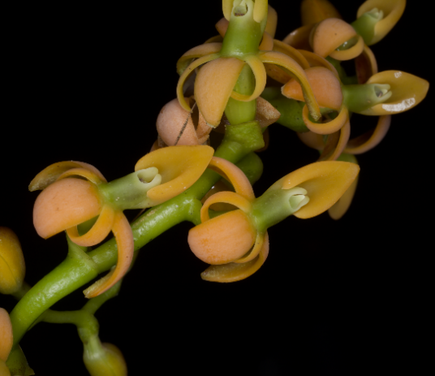  Epidendrum (aff. recurvitepalostachyum) | Epidendrum (aff. recurvitepalostachyum)  It may be a new species, currently under review and identification process, which may take several months.
Pleurothallis aff. gomezii  It is a rare miniature orchid, which is in the process of identification and its only species so far considered the most similar is P. gomezii. | 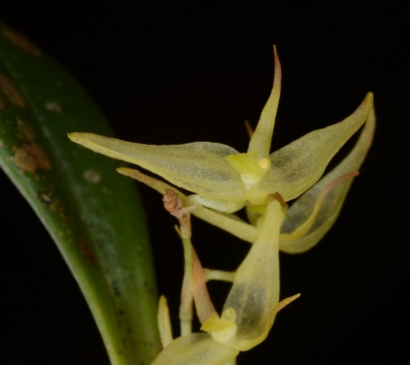  Pleurothallis aff. gomezii
Pleurothallis aves-seriales Luer & R.Escobar (Var. Xanthina)  A little known coloration for the species. It is a simple phenotypic variation, but that does not make it less showy. | 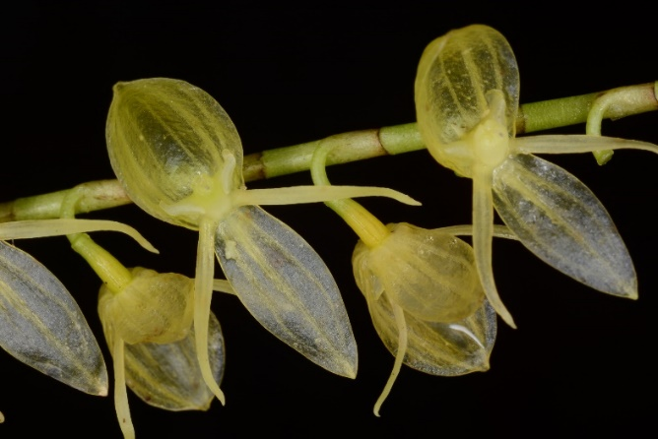Pleurothallis aves-seriales Luer & R.Escobar (Var. Xanthina)
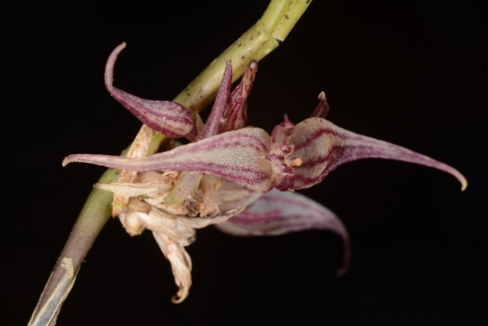  Pleurothallis sp. nov.(Grupo Chloroleuca) | Pleurothallis sp. nov.(Grupo Chloroleuca)  It is still being determined whether or not it is a new species not described in science. It is presumed that its color and shape differ completely from the other 3 species that are very similar to it.  A little known coloration for the species. It is a simple phenotypic variation, but that does not make it less showy.
Pterostemma antioquiense F. Lehm. & Kraenzl. ex Kraenzl.  It has been little studied but it is a real botanical jewel. It looks like reddish fans with semi-flat leaves that turn red with increased exposure to the sun, its yellow flowers stand out against the color of the plant. Photograph taken from the Colombian Society of Orchidology in its virtual page. | Pterostemma antioquiense F. Lehm. & Kraenzl. ex Kraenzl.
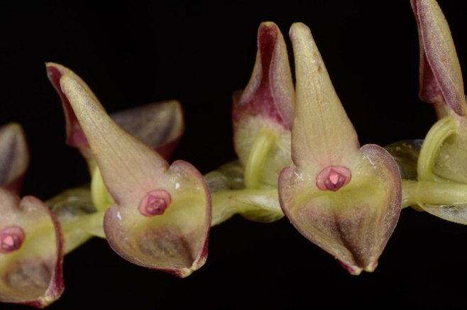  Stelis acutissima Lindl | Stelis acutissima Lindl.  A little-known species, abundant in its high mountain populations, predominantly on the most open and humid ridges and paths. Its flowers exceed 1 cm in length.
Lepanthes sp. nov. (aff. elata)  The most similar species is l. elata, but it differs completely in its column and labellum. It has already been confirmed that this is a new undescribed species in process of description. | 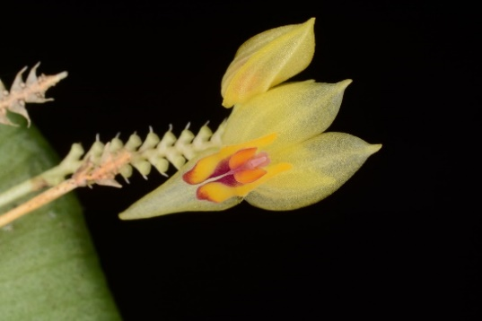  Lepanthes sp. nov. (aff. elata)
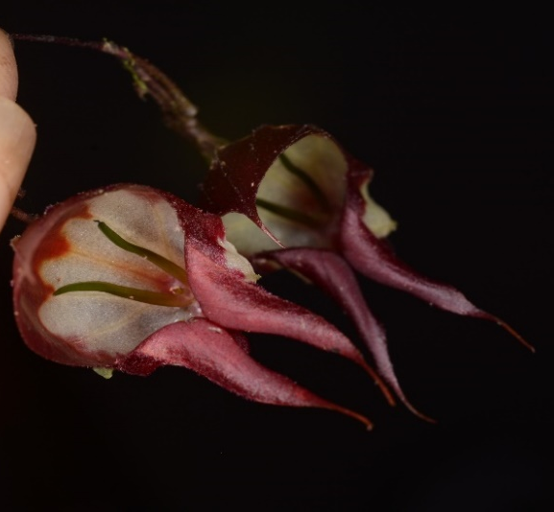  Lepanthes sp. nov. (aff. felis) | Lepanthes sp. nov. (aff. felis)  New species, related to L. felis, L. caprimulgus and L. ribes; perhaps the largest of the subgenus Marsipanthes to which it belongs. It is currently in the process of description and publication by Esteban Domínguez Vargas (Colombia) and Diego Bogarín (Costa Rica).
Lepanthes sp. nov. (cf. ophelma)  Species still in the process of identification, the possibility that it is a variation of L. ophelma or L. hortensis is being ruled out. | 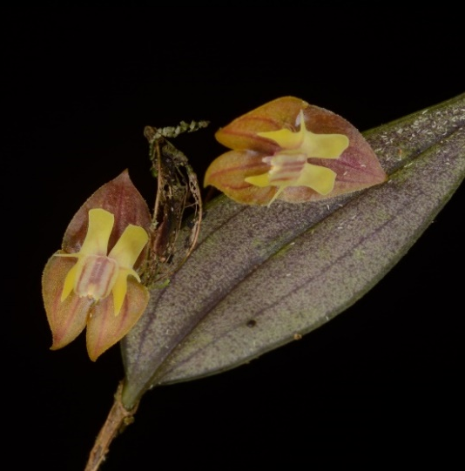  Lepanthes sp. nov. (cf. ophelma)
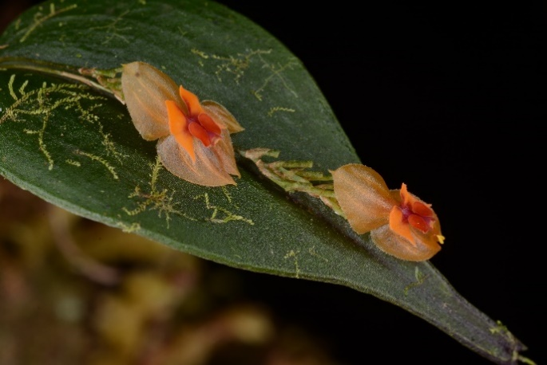  Lepanthes sp. nov.(aff. escifera) | Lepanthes sp. nov.(aff. escifera)  It has already been confirmed that this is an undescribed species, it is in the process of publication and its principal investigator is Sebastian Vieira.

ANNEXES
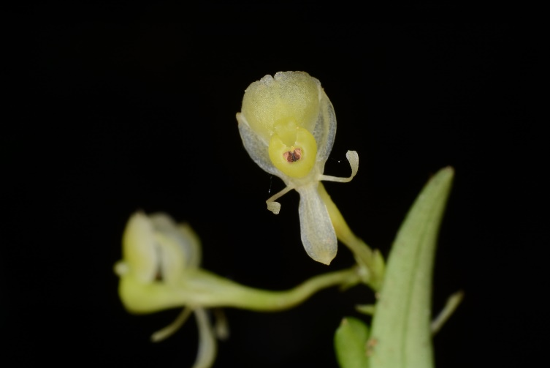
Fig. 2. Acianthera rodrigoi
Fig.3. Epidendrum sp.

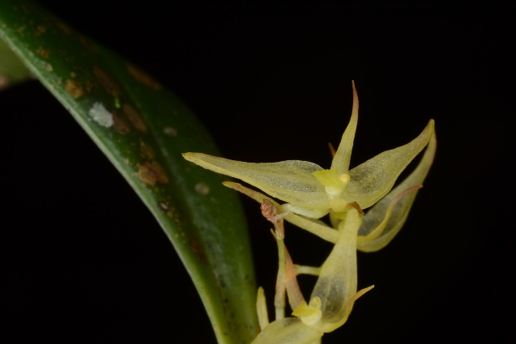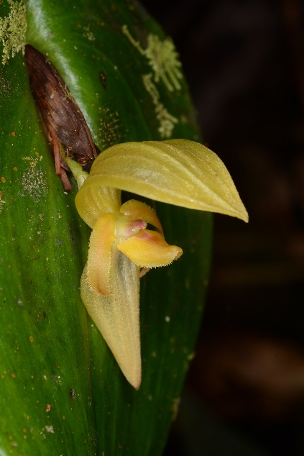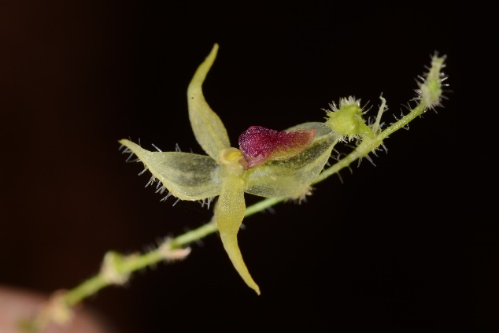
Fig.6. Salpistele calceolaris
Fig.4. Pleurothallis aff. gomezii
Fig.5. Pleurothallis megalorhina
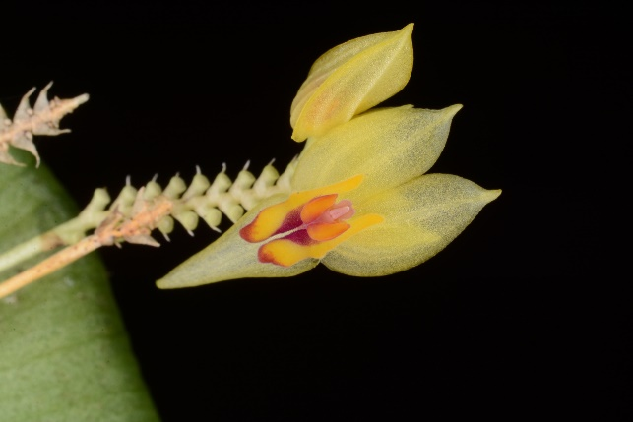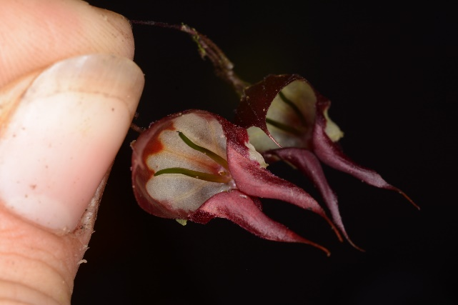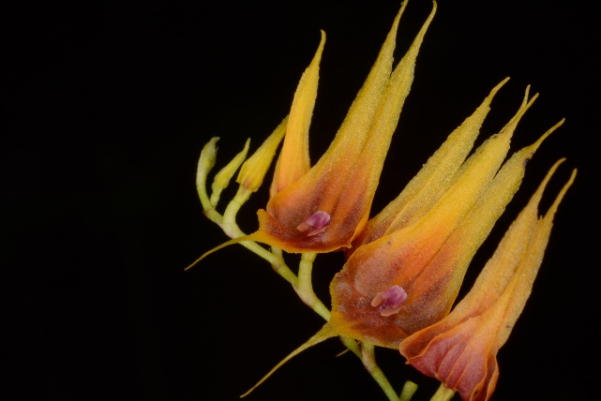
Fig.9. Lepanthes tibouchinicola
Fig.8. Lepanthes sp. nov *
Fig.7. Lepanthes sp. nov *

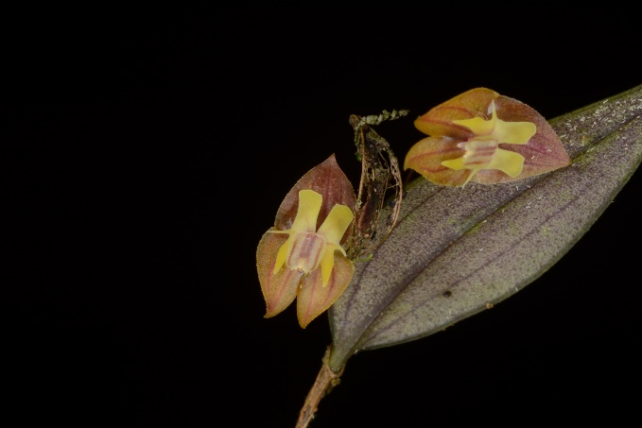
Fig.10. Lepanthes sp. nov. *
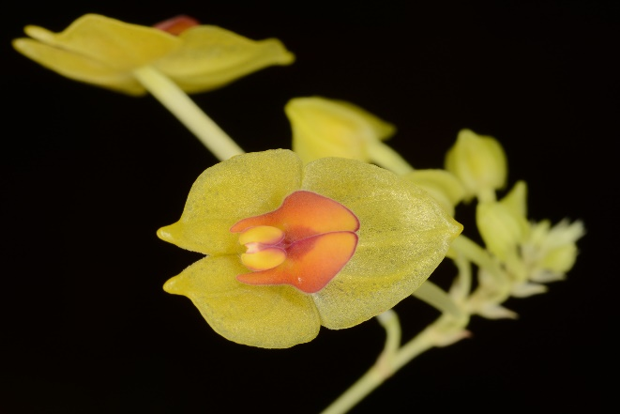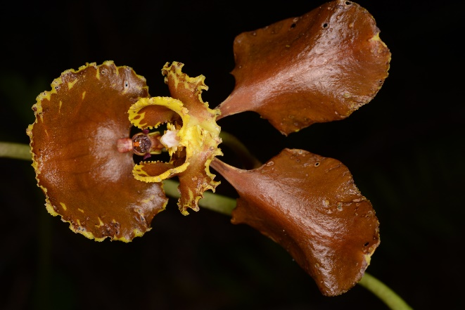
Fig.12. Cyrtochilum annulare
Fig.11. Lepanthes gargantua

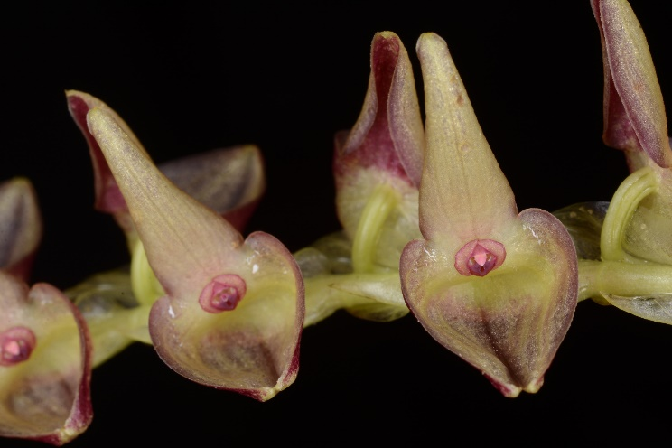
Fig.13. Stelis acutissima

ACKNOWLEDGMENTS
Once again, it is worth mentioning the gratitude expressed by all the participants for the donation made by the American Orchid Society for the realization of this characterization, which is really crucial in order to know our biodiversity and add value to the conservation work.
We thank the Fundación Guanacas Bosques de Niebla for all the logistics of the trip, the project funder, and the JAUM herbarium for the drying and storage of the specimens. To the expedition members Elizabeth García, Alejandra Serna, Juan Pablo Tobón and Juan David Molina for their support in the collection of samples and for all their wisdom shared during the trip. To the guides Juan Macías, Henry Londoño and Germán Macías for their accompaniment and permanent help in any of our actions and walks in the reserve.

REFERENCES AND BIBLIOGRAPHIES REVIEWED
Calderón-Sáenz E. (ed.). 2006. Libro Rojo de Plantas de Colombia. Volumen 3: Orquídeas, Primera Parte. Serie Libros Rojos de Especies Amenazadas de Colombia. Bogotá, Colombia. Instituto Alexander von Humboldt - Ministerio de Ambiente, Vivienda y Desarrollo Territorial. 828 p.
L.A. Arias, 2011 Catálogo de las plantas basculares del departamento de Antioquia, Flora de Antioquia. Volumen 1. Capítulo , “Estructura, Clasificación y Evolución del Relieve en el departamento de Antioquia” pág. 34-37
L.S. Espinal et. G.Vásquez-Velásquez, 2011. Catálogo de las plantas basculares del departamento de Antioquia, Flora de Antioquia. Volumen 1. Capítulo “Zonas de Vida del Departamento de Antioquia. Anotaciones y complementos”, pág. 234-293
Ministerio de Ambiente y Desarrollo Sostenible y Universidad Nacional de Colombia. 2015. Plan para el estudio y la conservación de las orquídeas en Colombia. Textos: Betancur, J., H. Sarmiento-L., L. Toro-González & J. Valencia. Ministerio de Ambiente y Desarrollo Sostenible, Colombia; Universidad Nacional de Colombia, Bogotá D.C. Pp.336

